WEEK 7/ 8 Log

1. Enable virtual machine

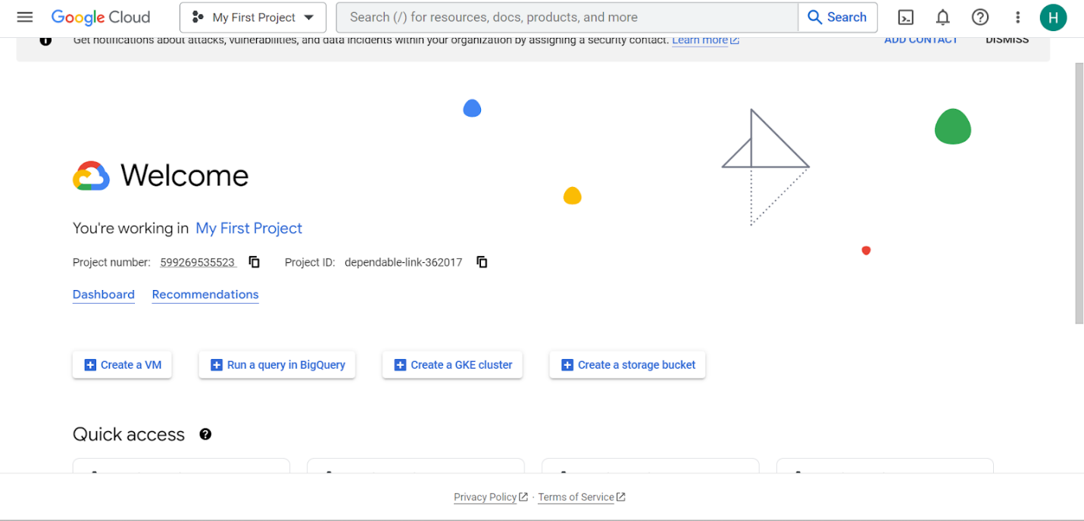

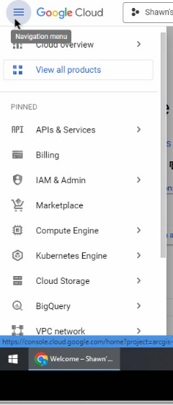

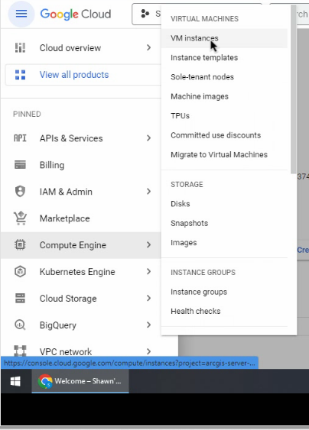

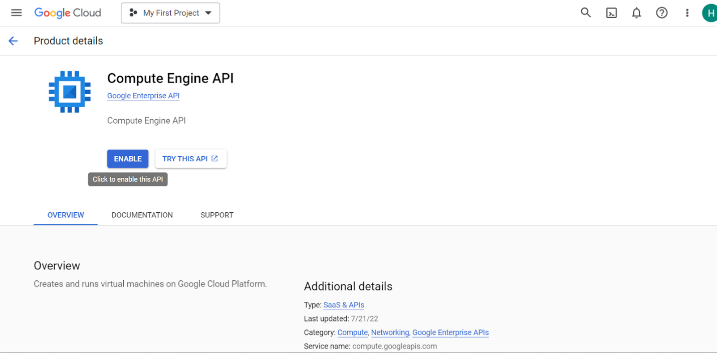

2. Click “Create instance”

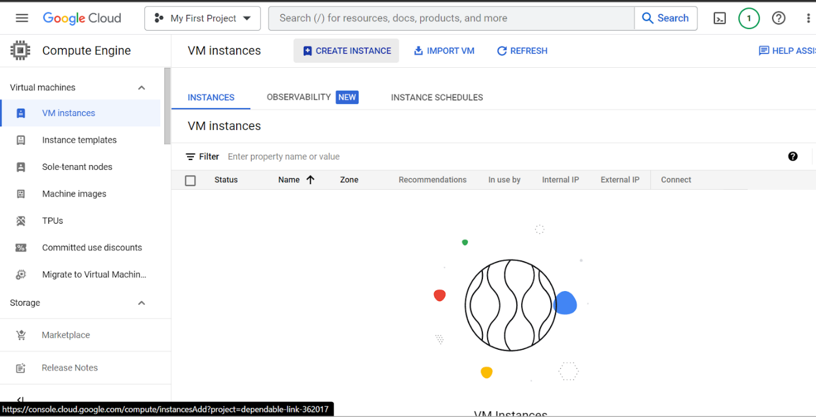

3. Name it:

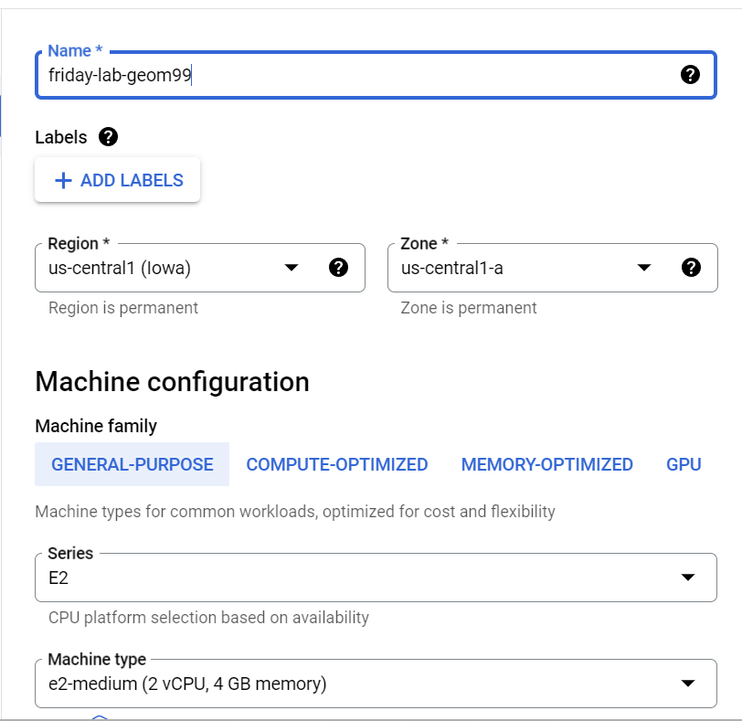

4. change boot disk image

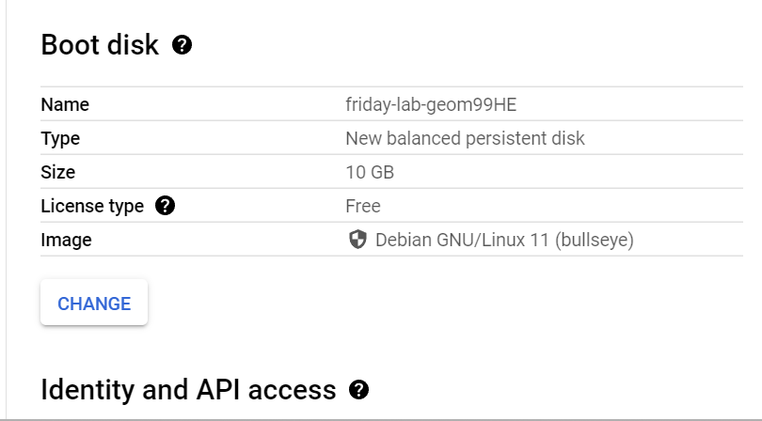

^^ pointing at the Linux server, BUT we want the virtual machine image Shawn created for us, TF: change this

Choose “custom image” cause getting image from Shawn

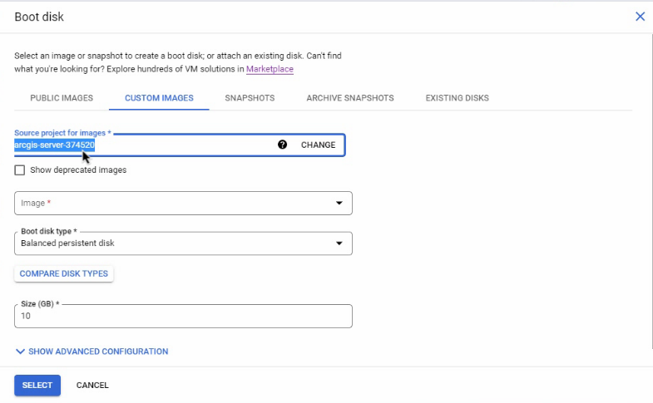

… click CHANGE this

Go to ALL projects and choose Shawn’s Project that he created (on his google cloud) to see his image/ vm

TF: his project contains a copy of his Virtual machine/ image/project with the college’s server on it

…. Now can paste it to our project (make a duplicate of it) the o have same access to the vm/ image!

**NOTE: this vm/ image has the college’s server set by Shawn up on this vm

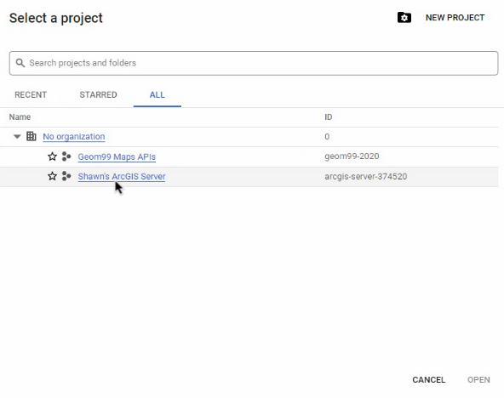

^^^ It will now take copy of the hardrive/ image and move it/ paste it to yours (tf: create a duplicate)

(note: this is why we had to provide him with our emails for this step so that he could enable each user to see his project, which let’s us see his VM/ image with college’s server so that we could access it and paste it to ours…. For security reasons, cause not good if anybody could access this and see details about the college’s servers)

…Now, change firewall rules:

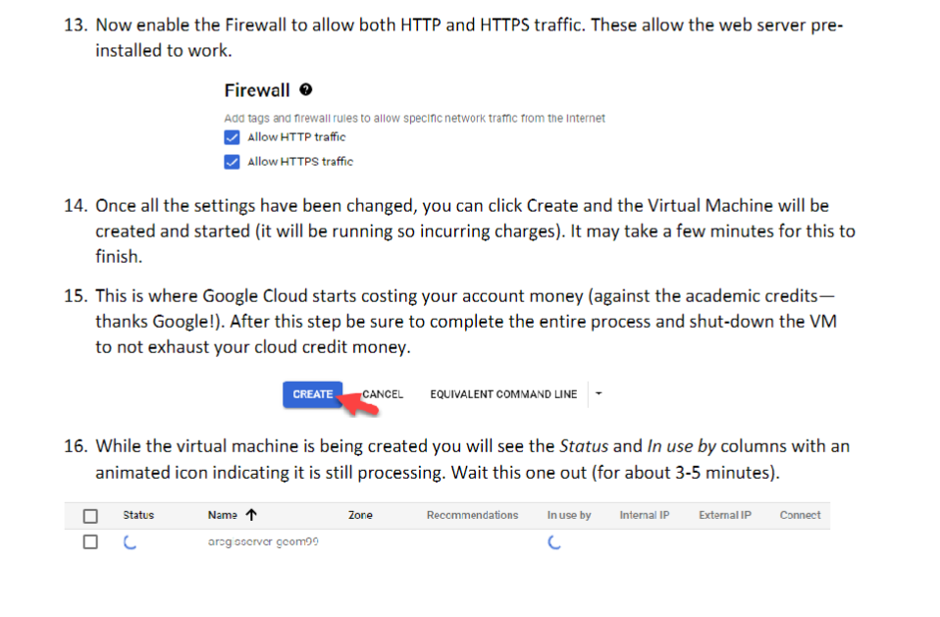

NOW:

Can see what you created:

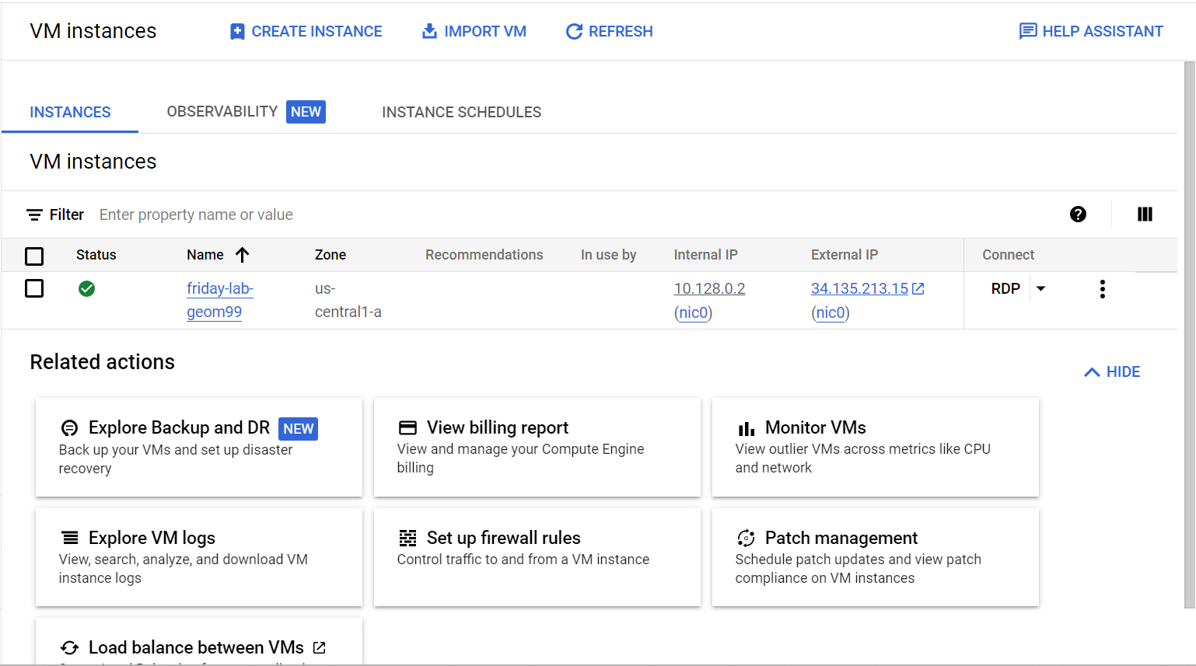

^^ the green checkbox== means your server is open and running (DONT leave it like this)

NEXT: 2 things to do:

Enable firewall rules to let **Arcgis server** work and also to let **remote desktop** work

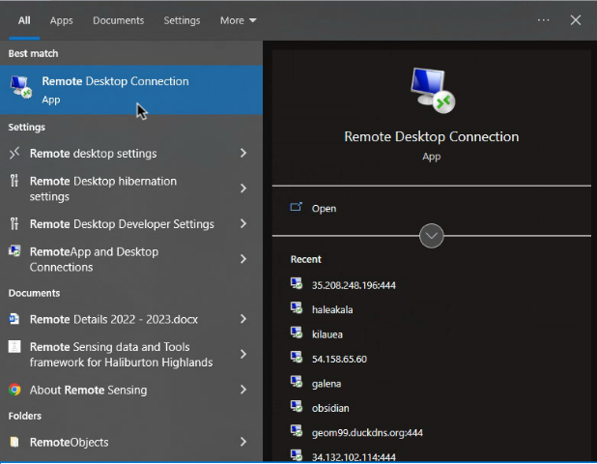

WHY do we set up firewalls next? Because we’re changing the default port of 3389 to 444, so we use port 444 when connecting to firewall

To do this, add :444 after whatever the external IP you’re using during that session (changes each time)

Example:

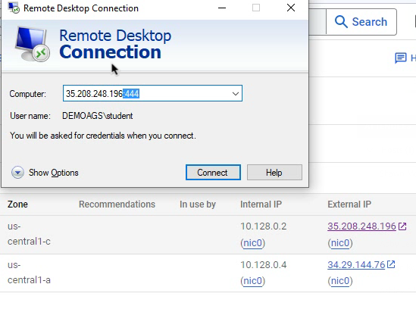

Note:

The Internal IP== Computer to computer in Ihoa (but we’re not in Ihoa)

Tf: we use the external IP

BUTTTT Port 444 isn’t set up in the firewall rules,,, tf: we need to set this up before trying to connect to remote desktop with port 444

Firewall rules (**Arcgis server and Remote Desktop)**:

5. Go to firewall and Create firewall rule to allow port 444 to be open

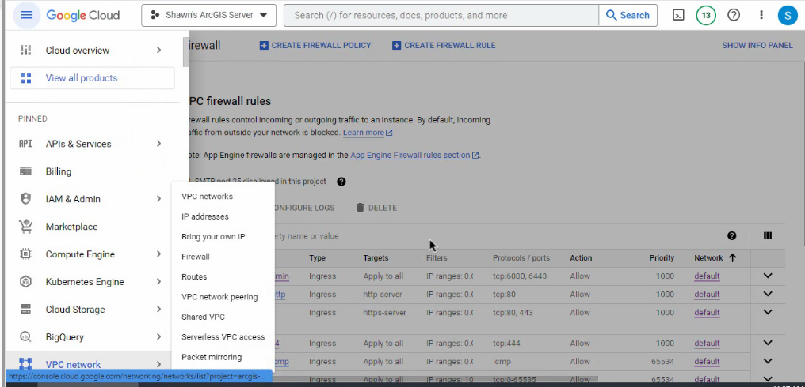

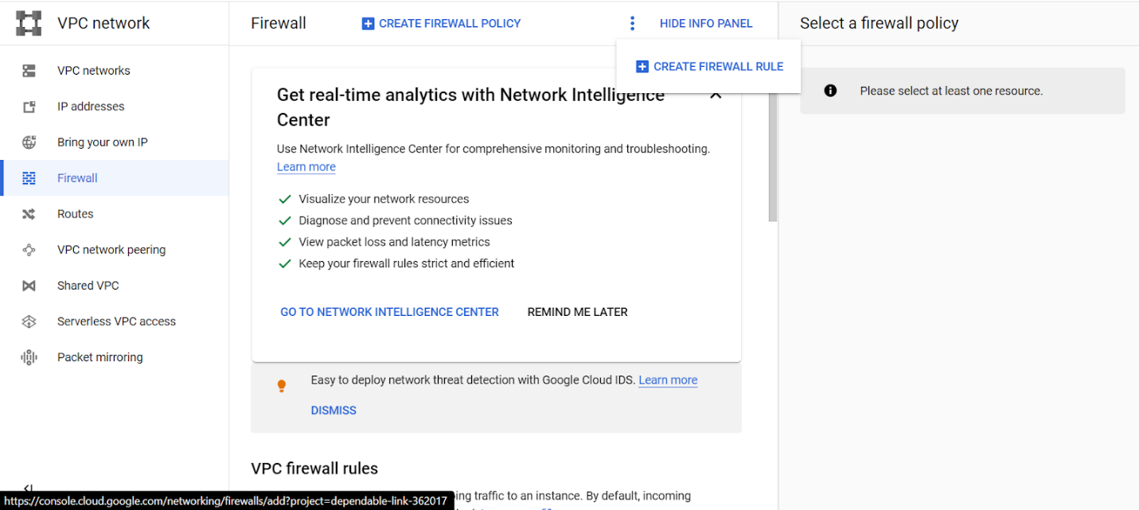

6. Name the firewall rule

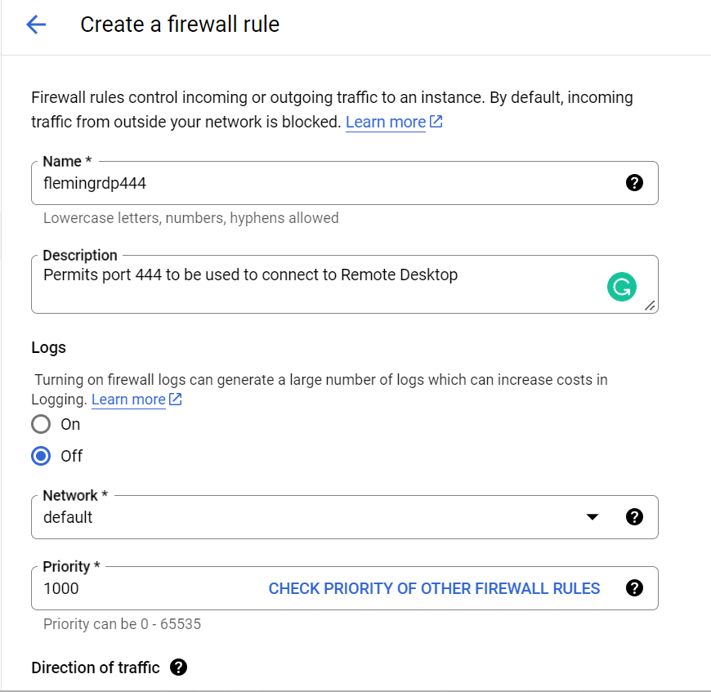

7. Allow for in-bound/ ingress

TF: choose “all instances in the network”

… this will allow port 444 for ALL of your virtual machines on your computer

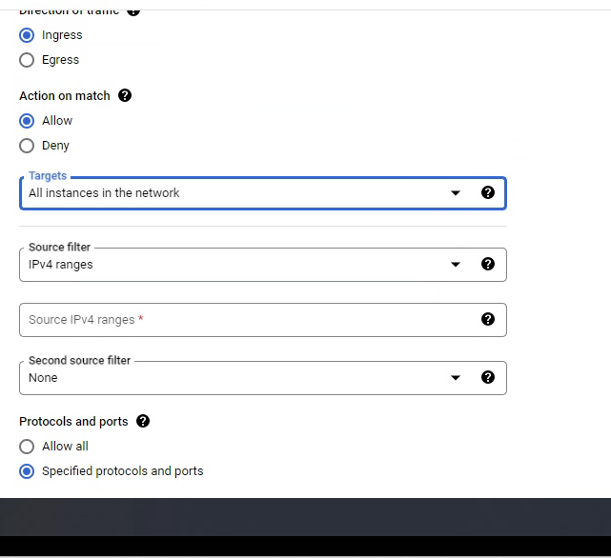

8. choose “Source IPv4 ranges” (the external IP, tf: your personal IP address (or whatever you IP address/ location you choose, ex: could be from VPN), tf: you can set it up so only you (or whoever is at that IP address) can access it

…. NOTE: you change locations or use VPN, you need to update your IP address in firewall settings each time (can do this by clicking edit this firewall rule– don’t need to recreate it)

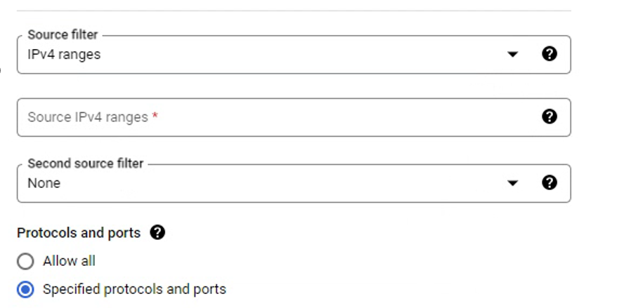

9. allow port 444 to connect to remote desktop

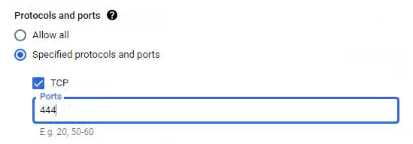

TF: now, ONLY your computer can access 444

10. create firewall rule to allow ArcGIS Server

Change name and make sure it is “Ingress”

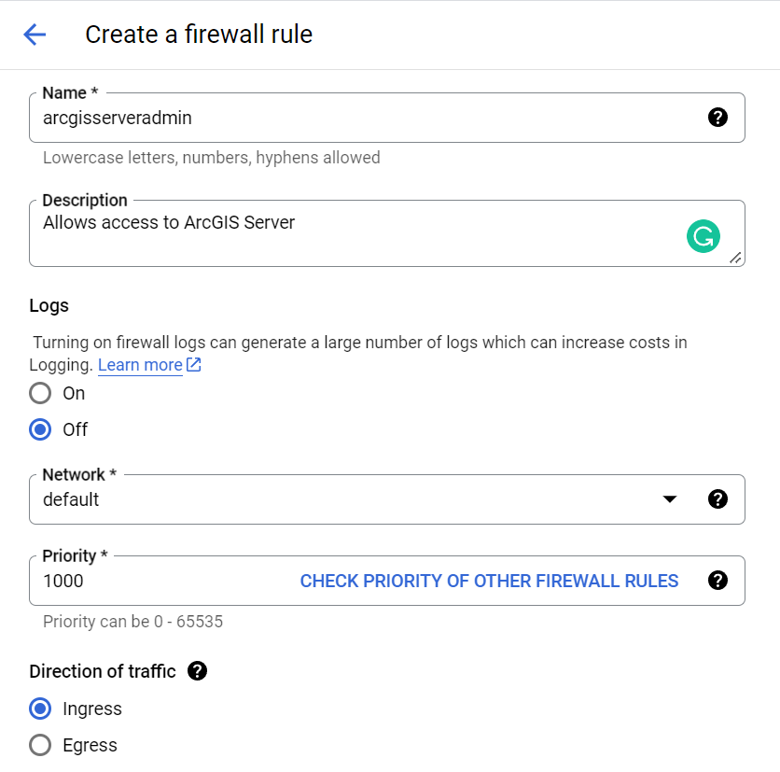

11. Allow all instance in the network to access it

Tf: choose IP address: 0.0.0.0/0

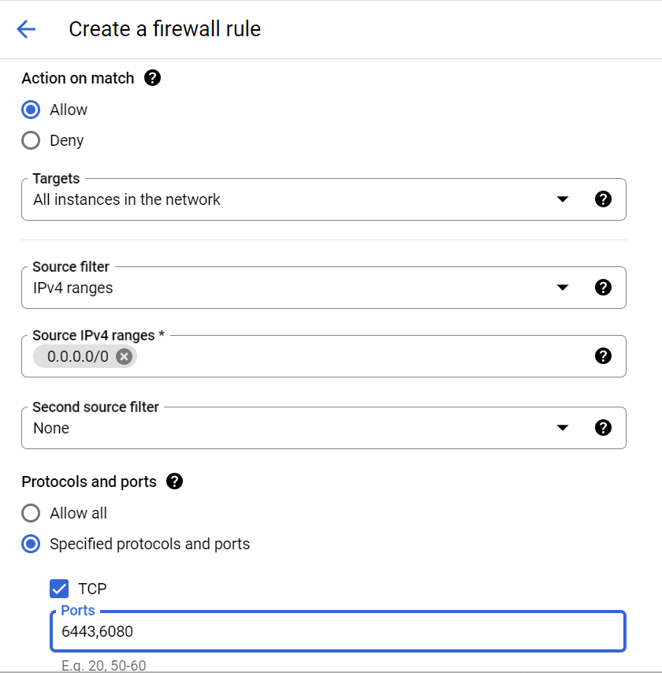

12. Allow ports 6443 and 6080

^^^^^^^^^ You could technically put both firewall rules into one, but best practice is to separate them so you can control who sees what

NOTE: YOU CAN TEST THIS OUT WITHOUT CONNECTING TO THE SERVER YET:

Take the external IP address and add to the start of arcgis/rest/services url

Example:

https://34.135.213.15/arcgis/rest/services

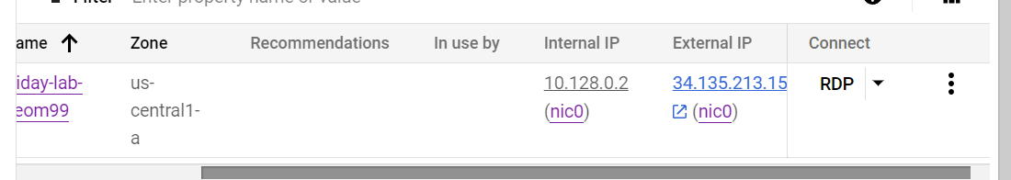

Example of what the page will look like:

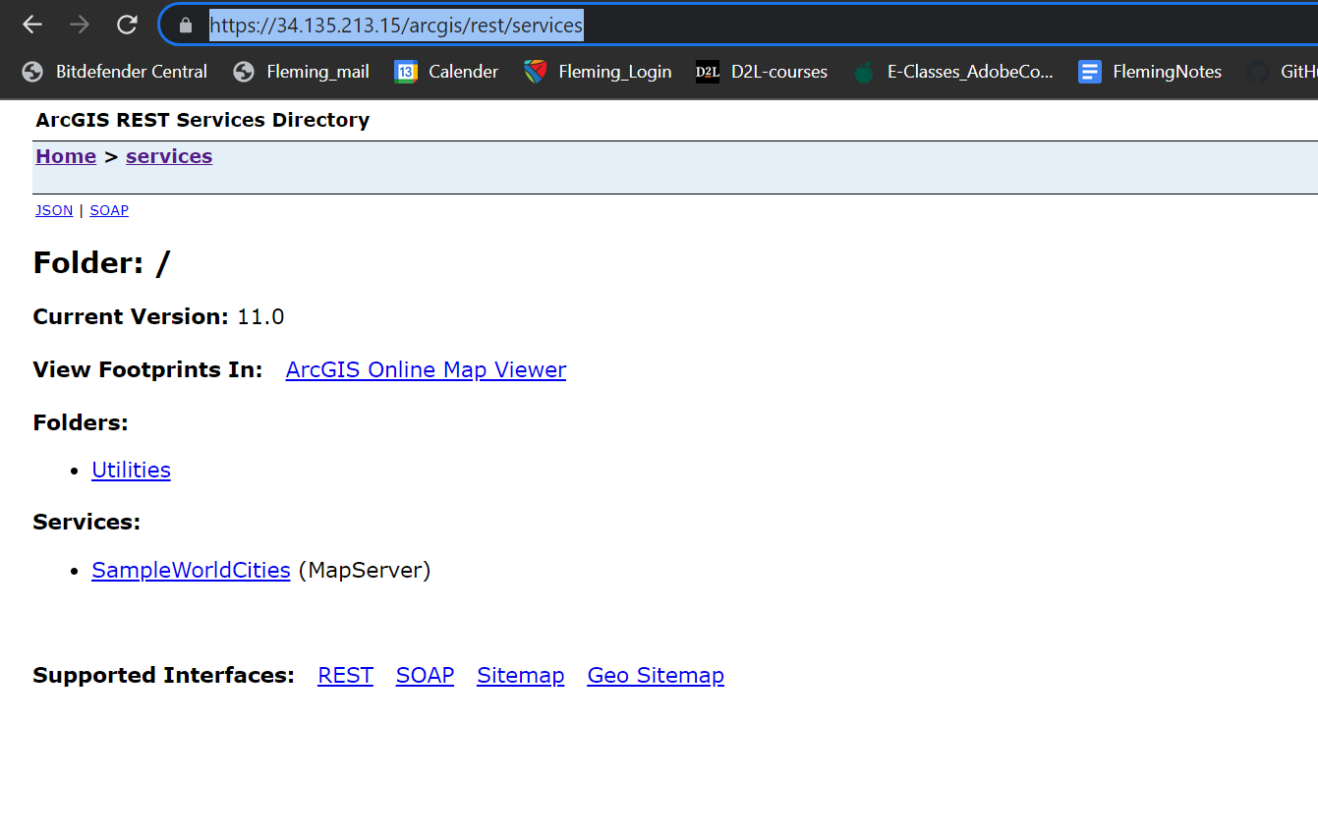

……………………….

13.

**Set username to “student”** and it will generate a password

*** SAVE this password/ write it down somewhere to save so you have for the next times you’re logging on to Virtual Machine

To do this, go to the main VM instances page and click the drop-down from the RDP to set password:

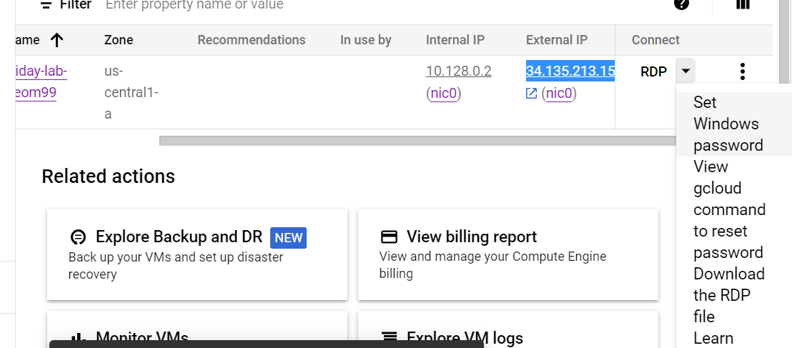

You MUST USE student cause that’s what Shawn has set up for us (or else it’ll create a new user,, but will be blank, tf: can’t really use it)

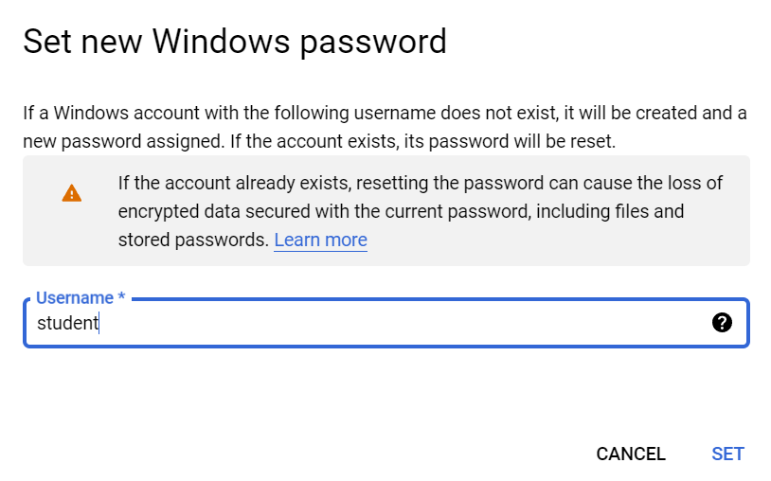

Now– it reaches in and RESETS the password (a popup appears showing it, but this is the ONLY time you’ll see the password– tf: write it down)

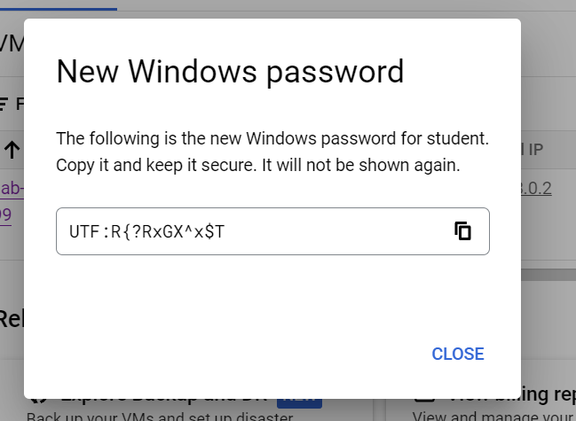

…..

14. **NOW you can connect to Remote Desktop** (because you have a password set up and firewall rules/ ports set up)

15. Search for remote desktop on personal computer and put in the EXTERNAL IP address of that session (followed by the :444 port)

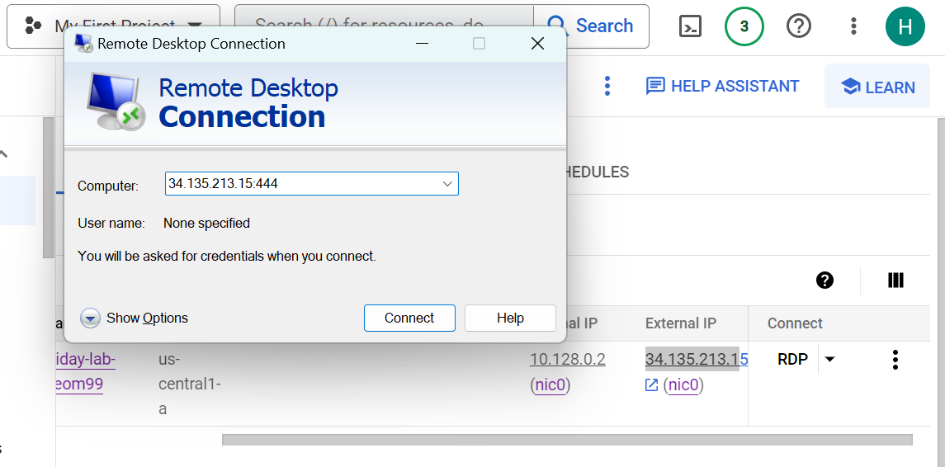

16. Use the **student** credentials to sign in

TF: student username and the password you just generated and saved

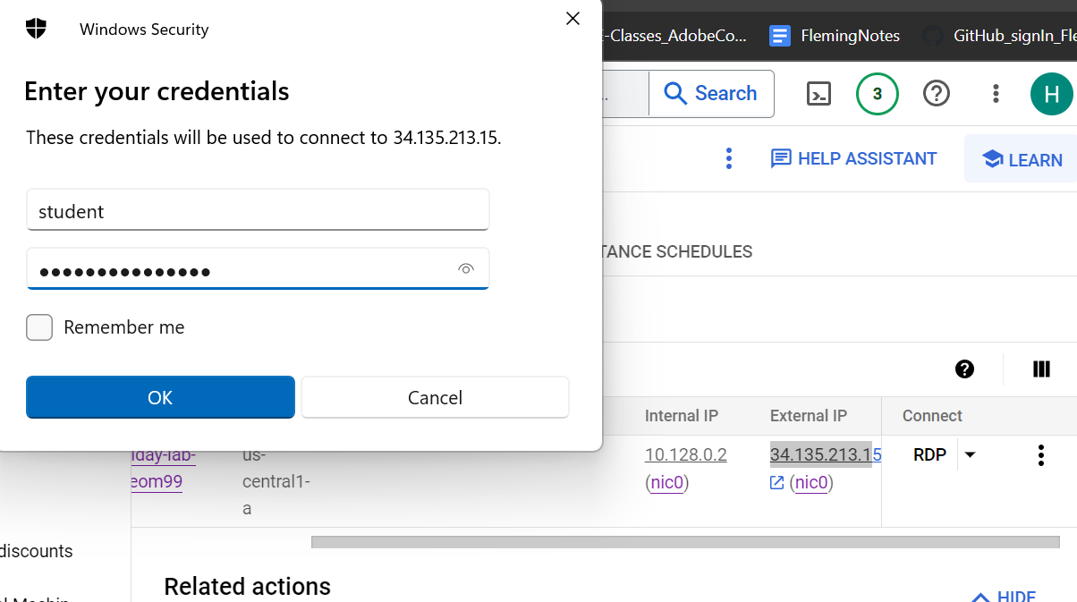

Then, you are connected:

17. To access the Server manager site, login with the server credentials provided:

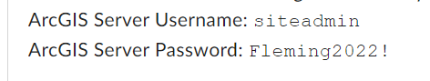

Siteadmin

Fleming2022!

18. To access this page from personal computer, open browser and type the external IP address from that server’s session, followed by arcgis rest services url:

Example:

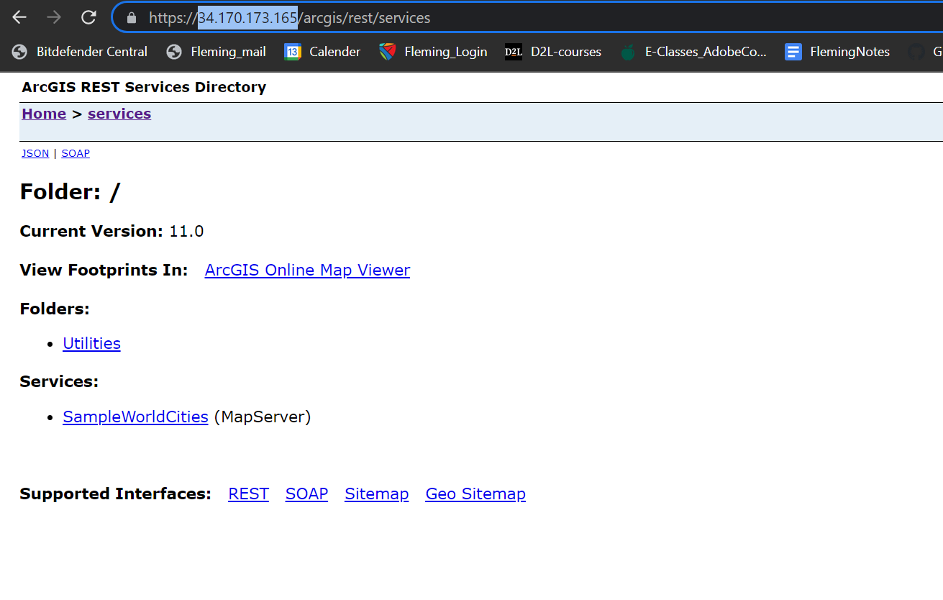

19. Choose a layer under SampleWorldCities (for example, choose the cities layer), and you will see the rest endpoint of that layer (the cities layer)

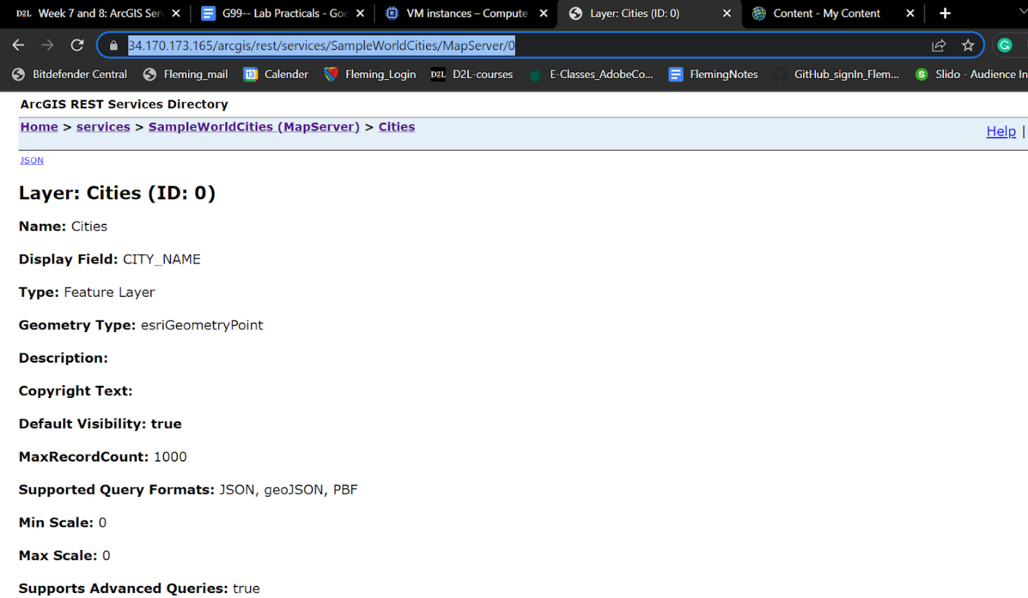

20. To add this item to AGOL, use the same URL when creating new item:

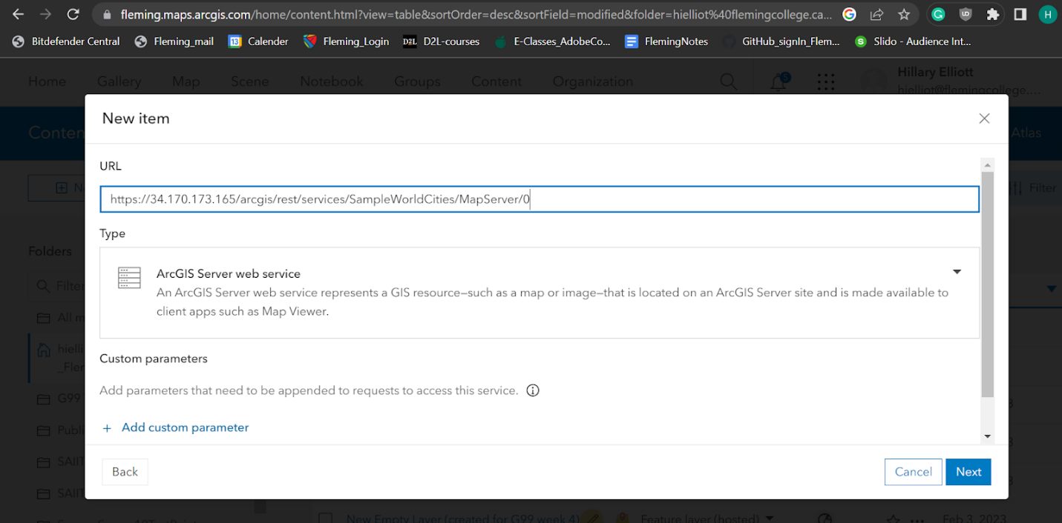

21. To register a data folder, go to the data store on the Server Manager site

Log in with these credentials:

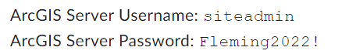

22. Go to Data Store and choose dropdown that says “Database” and change to foler (this will register the folder)

23. Name the folder you upload

Make sure the folder has the same path as the directory on your computer

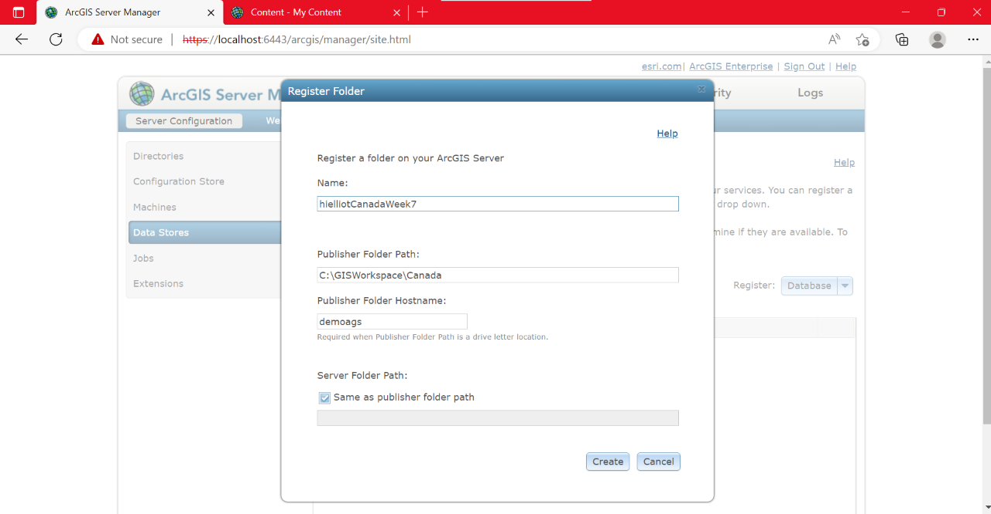

24. When registering the folder ^^ The publisher folder hostname is the name of the computer (the VM computer)

Find this in setting of the VM

The name is gemoags, tf: put this as folder hostname

Then you will see it registered in the data store:

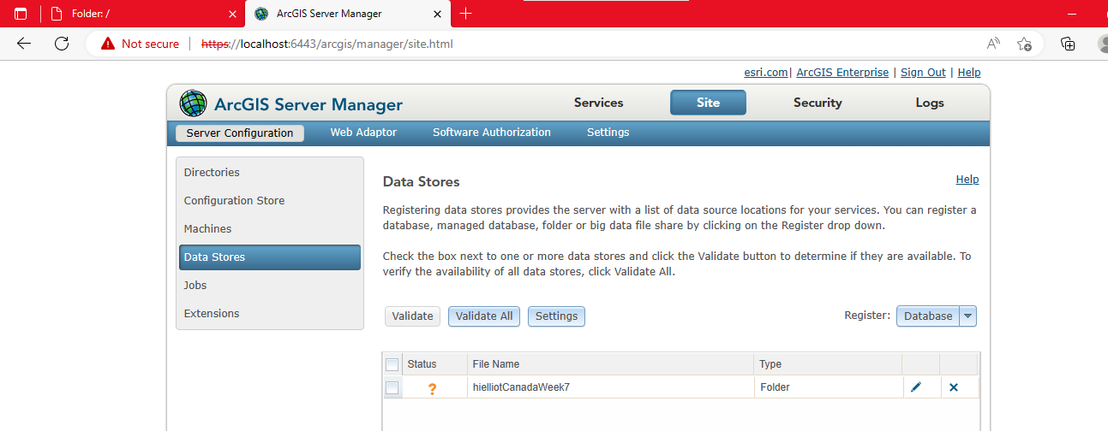

25. To register (then later publish) a map service from personal computer’s ArcPro, you can connect to the server (as long as it is running)

… To connect:

Use the IP address of that server session, followed by /arcgis (which is the home page of the server arcgis server site)

Next: Use the **ArcGIS server credentials** to sign in

Tf:

Username: siteadmin

Password: Fleming2022!

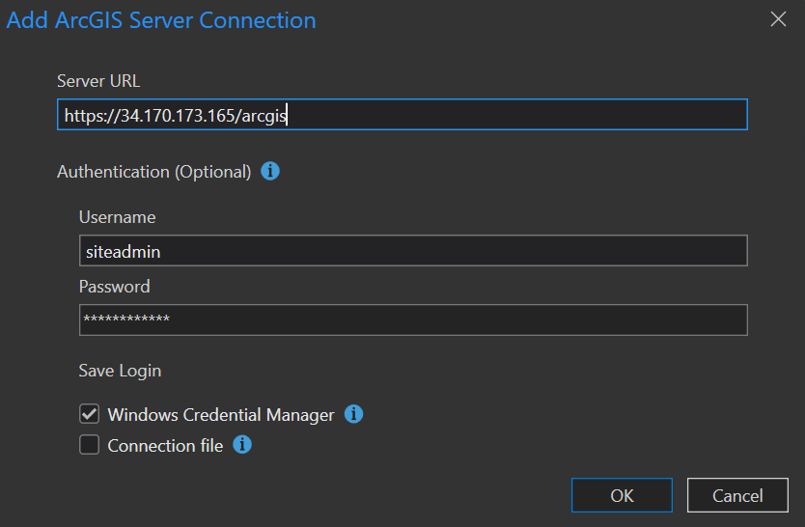

Once connected, if you click on properties of connected server, you can see the info:

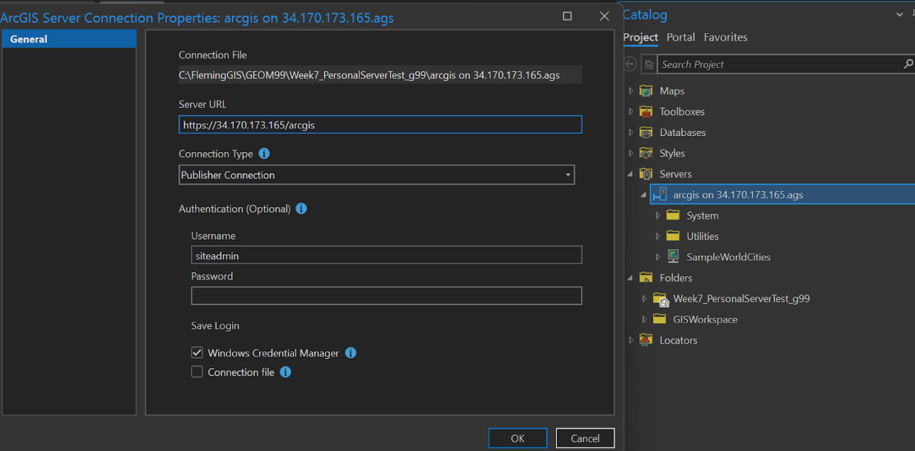

26. To publish a map service, right click the server connection again and choose to publish map service

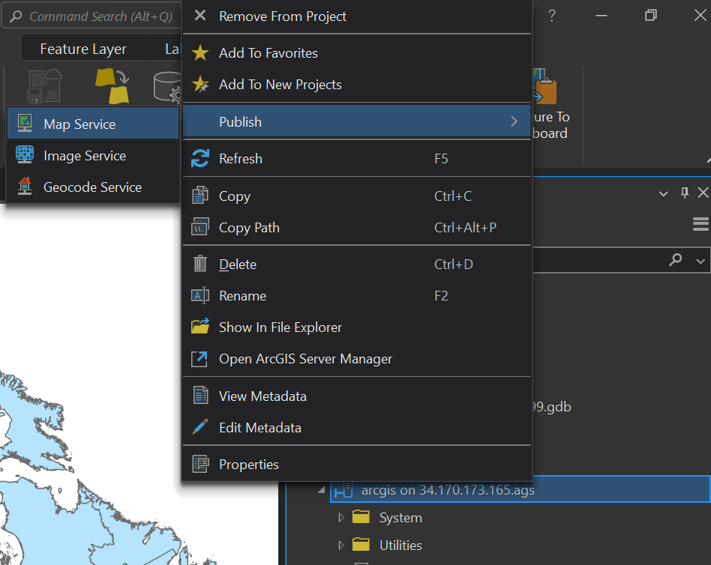

27. Select the map in the project that you want to publish:

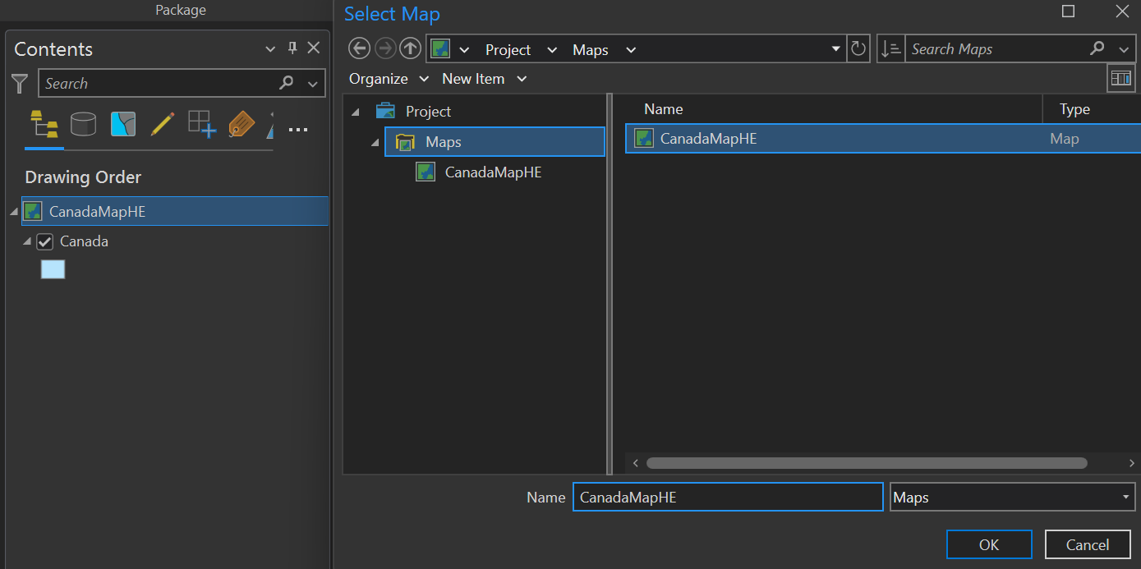

Note: Under content, you can see exactly what you’re publishing

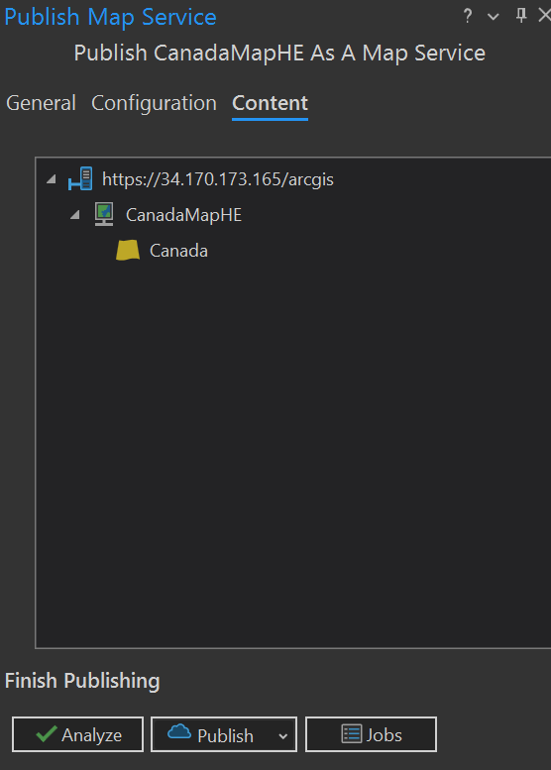

Note: Here you can specify a map service or feature service to publish

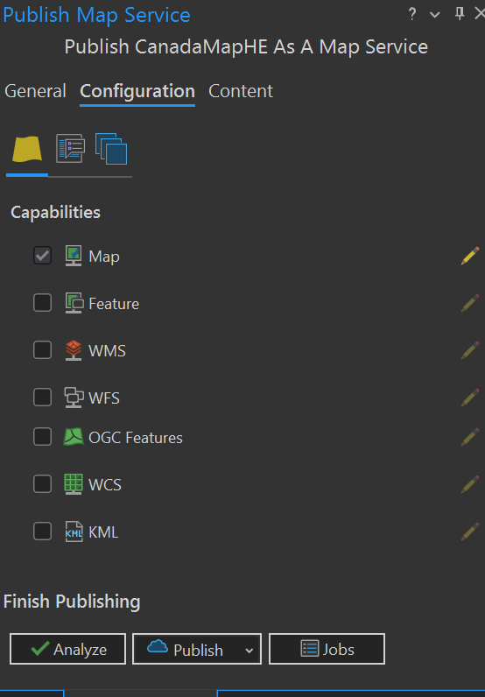

28. Choose folder where you want to publish to (or make a new folder)

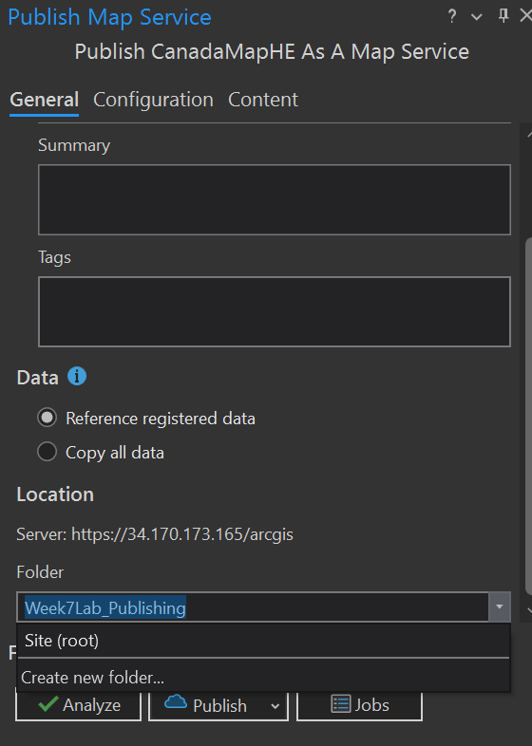

29. click **ANALYZE** before publishing

Fix all the errors that appear (especially registering the folder)

TF: register the folder:

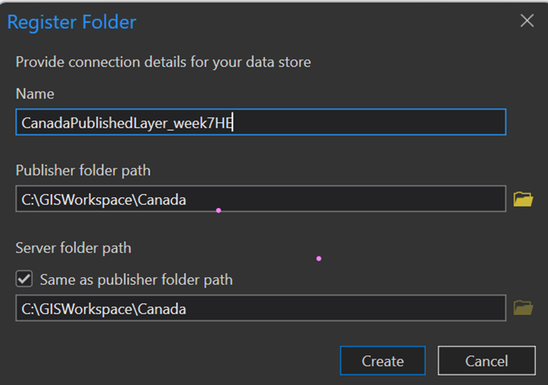

30. Once there’s no more errors, click **publish**

You will see the results in the server manager site

(in this example, in a new folder as that’s what was specified in ArcPro)

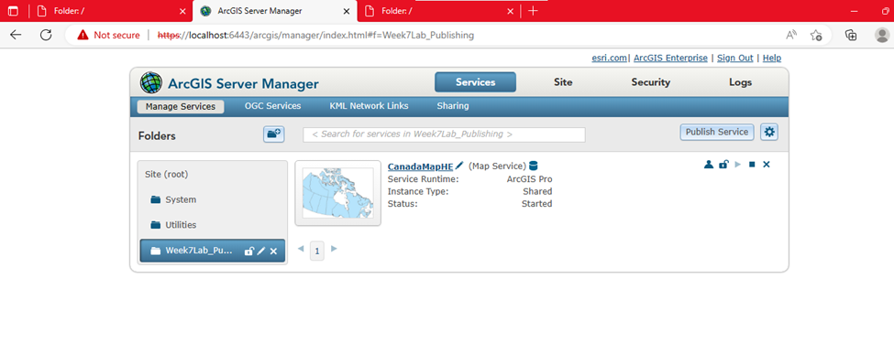

……………………..

31. To actually close down the VM, you can’t just log out or click X to exit the remote desktop…

You need to actually hit **shut down** (or else the green check mark is still running/ your server is running and using credits!!)

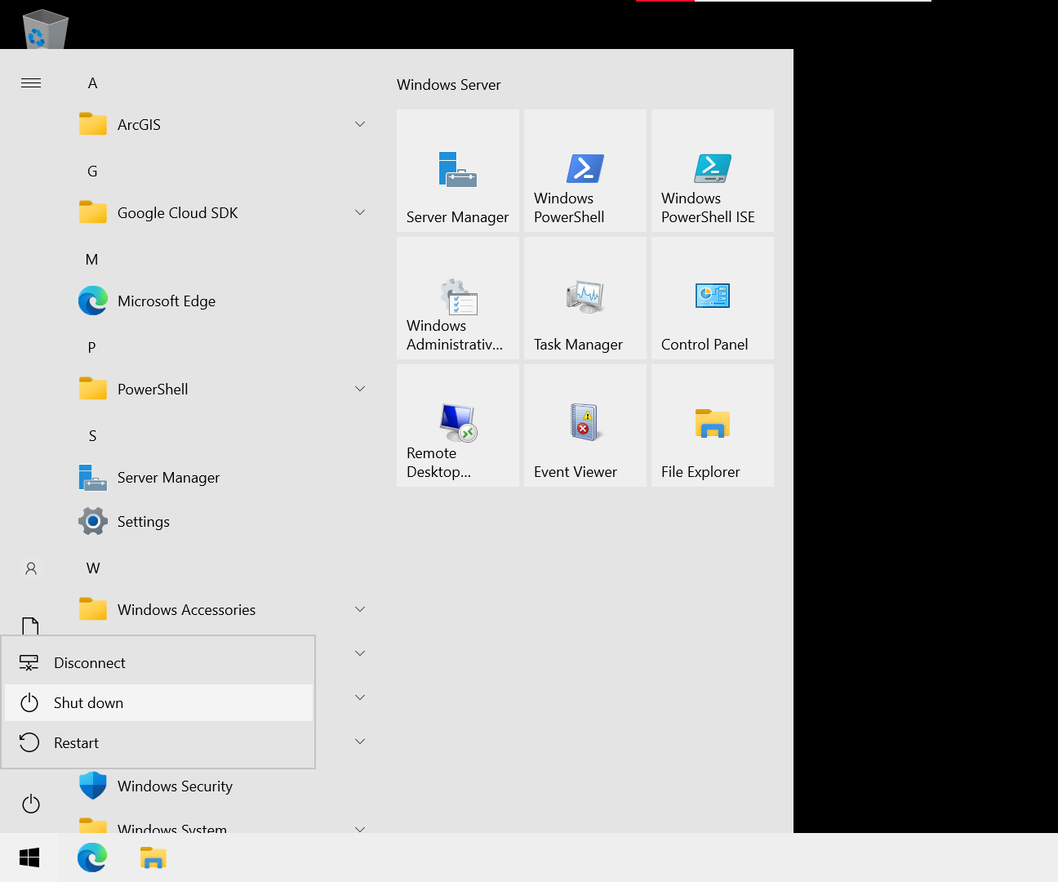

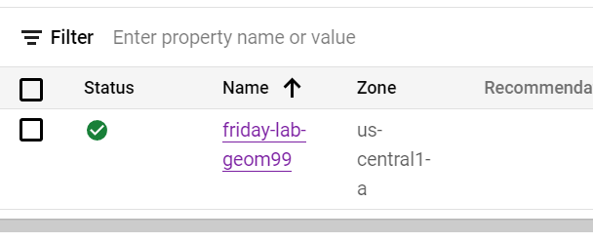

32. To shut down the server, choose to STOP the server so not constantly running/ using credits

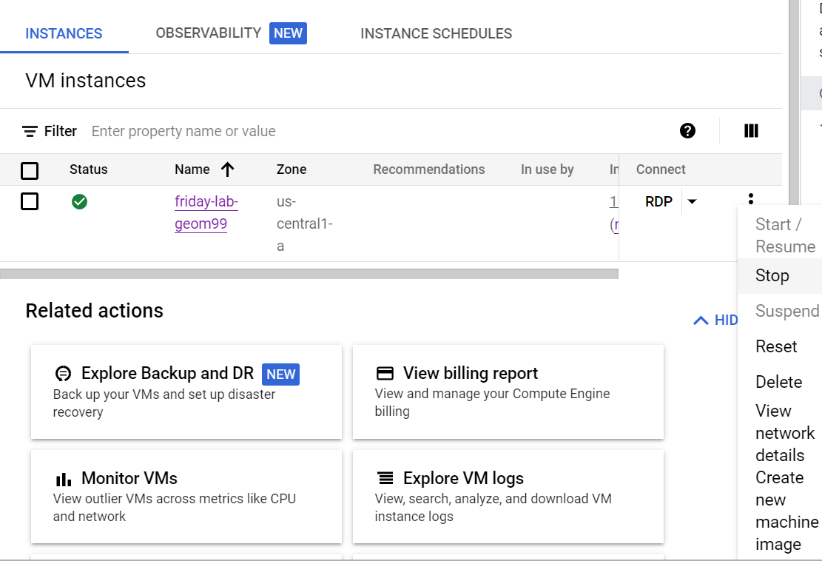

Once shut down, it will look like this (no more green check):

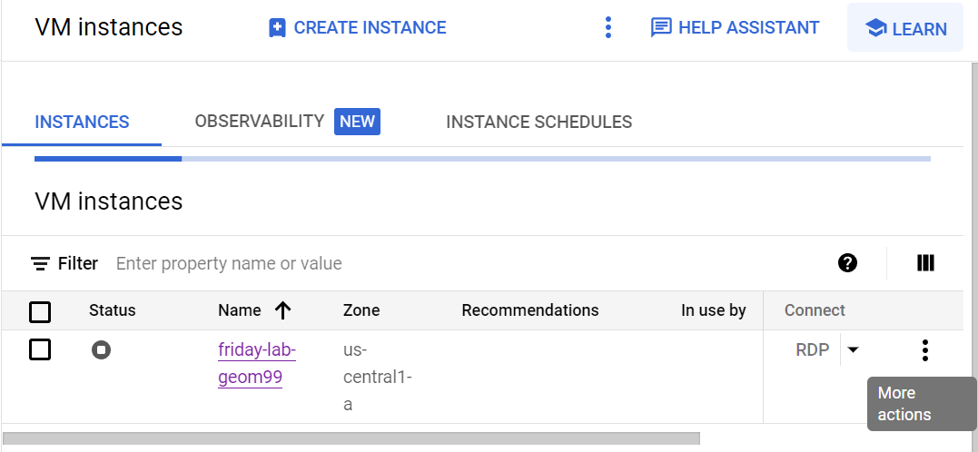

OR, If can’t log into remote desktop to shut down the VM, just click “Stop” on the server here and it will shut down both the VM and server at once (but best to shut down the remote desktop first, and then server)